

APPLYING FEDERATED LEARNING WITH SMART CONTRACTS IN HEALTHCARE

## PROJECT SUPERVISOR

Dr. Farrukh Shahid

## PROJECT CO-SUPERVISOR

Mr. Shahbaz Siddiqui

## PROJECT TEAM

Sarmad Jamal K191116

Khizer Jilani K191057

Mansoor Butt K191114

Submitted in partial fulfillment of the requirements for the degree of Bachelor of Science in Software Engineering.

FAST SCHOOL OF COMPUTING

NATIONAL UNIVERSITY OF COMPUTER AND EMERGING SCIENCES KARACHI CAMPUS

July 2023

# Acknowledgement

We would like to express our deep appreciation to our supervisor, Dr. Farrukh Shahid, whose invaluable support, constructive criticism, and unwavering encouragement were instrumental in the development and refinement of this project. His expert guidance and insights proved to be an invaluable asset, and we could not have completed this project without his guidance.

We also extend our sincere gratitude to our co Supervisor Mr. Shahbaz Siddiqui, particularly for their guidance and mentorship throughout the project. Their expertise and support helped us navigate various challenges and develop an optimized, efficient solution that met our project's objectives.

Furthermore, we would like to acknowledge the financial and emotional support of our parents. Their unwavering belief in our abilities and moral support helped us remain focused and motivated throughout the project's duration.

In conclusion, we express our heartfelt appreciation to all those who contributed to this project's success, and we hope that this work will prove to be a valuable contribution to the academic community.

# Abstract

This FYP project aims to address the problem of the lack of medical data sharing in healthcare, which is a major obstacle in integrating artificial intelligence (AI) technology. The reason behind the data-sharing hurdle is that medical data is highly confidential, and hospitals are reluctant to share it due to privacy concerns. As a result, machine learning (ML) models cannot be trained, and progress in this field is stalled. To overcome this issue, this project proposes an alternative approach, which involves model sharing and federated learning. The proposed system consists of two entities, the Super user and hospitals. The Super user requests hospitals to participate in federated learning, and registered hospitals are granted access to global model files through IPFS hashes. These hashes are stored on the block chain via smart contracts. The technologies used in this project include Solidity for smart contract development, React.js for the frontend, and IPFS Piñata for hosting ML model files. This solution provides a viable and secure way to enable AI integration in healthcare while maintaining patient privacy.

# **1** **Introduction**

Blockchain is utilized in healthcare management systems for secure maintenance of electronic health records. This research proposes integrating blockchain and Federated Deep Learning to develop a personalized recommendation system. To protect personal information, distributed storage is suggested. The study aims to make treatment recommendations by comparing patient records with historical data, addressing limitations of existing work. Incorporating federated learning can potentially enhance treatment recommendations.

# **1.1 Project Scope**

Our final year project focuses on the medical sector, where patient data is recorded and used to train a machine learning model. We employ the concept of federated learning, where multiple organizations collaborate to solve a machine learning problem without sharing or transferring data. A central server maintains a global shared model, distributed to each institution. Individual models are trained using localized patient data, and feedback from each center is aggregated by the server to update the global model based on predefined criteria. This iterative process continues until the global model is trained.

# **1.2 Not in Scope**

We will be only targeting one/two disease for the recommendation and it will be running on local environment not globally deployed. It will be on private block chain and only people who are connected will have the feasibility to connect to it

# **1.3 Problem Statement**

The problem statement addresses the challenges of centralized storage for training deep learning models in healthcare, including privacy, ownership, and regulatory concerns. Federated learning (FL) is proposed as a solution, allowing decentralized training without transmitting medical data. Medical institutions train their models locally and periodically share model parameters with a central aggregator server. The server coordinates and aggregates the local models to create a global model, which is then distributed back to the nodes. FL ensures data confidentiality by transmitting only model weights and parameters, offering improved security and enabling collaboration among institutions for healthcare applications such as predicting autism spectrum disorder, mortality, and ICU stay-time.

## 1.4 Project Objectives

The project aims to develop a secure system for medical data sharing in healthcare using federated learning and model sharing. Objectives include addressing privacy concerns, integrating AI technology, and enabling collaborative ML model training and sharing. Technologies such as Solidity, React.js, IPFS, and blockchain will be utilized to create a robust and scalable solution while ensuring patient data confidentiality.

# **Requirement Analysis**

# **2.1 Functional Requirements**

## 2.1.1 Functional Hierarchy

## The super Admin and providers have a specific identity number that identifies their account. The account is accessed via a special account address of web3 provider such as meta mask and for another way of authentication we will use firebase to authenticate the data

As data will be generated from multiple organizations, data must be accessible and consistent at all times. The integrity of the data must not be compromised.

**Features**

We have Implemented a user-friendly application user interface using React Js technology. It provides an interactive and responsive UI with adequate performance. The navigation from one page to another is explicitly shown.

The project included the following features with respect to super admin and providers (Healthcare institutions).

Login: Login page for super Admin and provider

Signup: Signup page for provider

functionalities related to provider

View Form: Doctor can view patient available respective data

Fill form: Receptionist will submit the form of the patient

Request a particular doctor: Receptionist can request a particular doctor

Take part in training: provider will have a functionality to train its model

functionalities related to super Admin

Retrieve model: super Admin can retrieve hospital model and make it interact with the global model

Aggregation of model: super admin will aggregate the model based on the weights of the different models

## Use Cases

## 2.2.1 Form Submission

[Use Case Diagram]

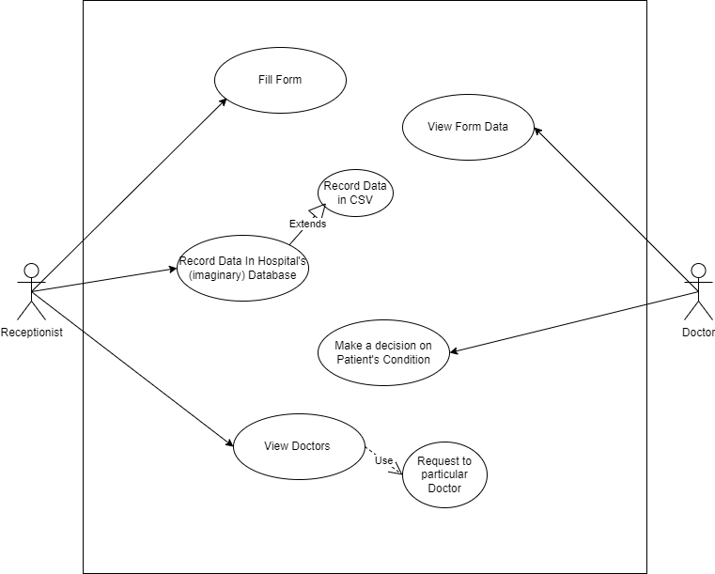

***Figure 1***

## Hospital/Super user Use Case

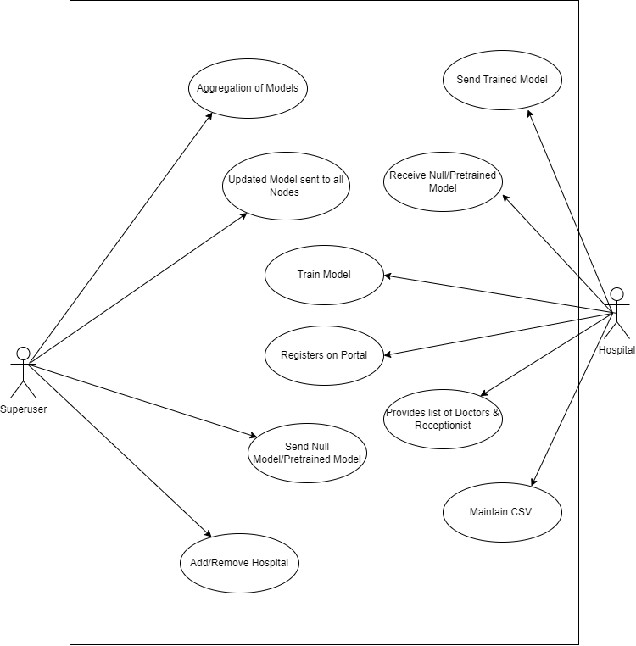

***Figure 2***

# **Non-Functional Requirements**

## Performance Requirement

Average load time of the login page of the system must be less than 1.5 second.

NFR01-02 Average processing time taken by the system to complete a transaction/request

should be less than 10 seconds.

NFR01-03 System Mean Time to Failure should not be more than 60 seconds within 24

hours of use.

NFR01-04 Average system response time should not be greater than 5 seconds.

NFR01-05 System must successfully run on a client machine with 256 MB RAM or above

Average load time of the login page of the system must be less than 1.5 second.

NFR01-02 Average processing time taken by the system to complete a transaction/request

should be less than 10 seconds.

NFR01-03 System Mean Time to Failure should not be more than 60 seconds within 24

hours of use.

NFR01-04 Average system response time should not be greater than 5 seconds.

NFR01-05 System must successfully run on a client machine with 256 MB RAM or above

The System shall be based on web and has to be run from a web server. The system shall take initial load time depending on internet connection strength which also depends on the media from which the product is run. The performance shall depend upon hardware components of the client/customer

## Safety Requirement

The software is completely environmentally friendly and does not cause any safety violations. The web page will have a flexible font that can be zoomed so as to not over constrain the eyes.

## Security Requirement

### Data Transfer

* The system shall use secure sockets in all transactions that include any confidential customer information.
* The system shall automatically log out all customers after a period of inactivity.
* The system shall confirm all transactions with the customer’s web browser.
* The system shall not leave any cookies on the customer’s computer containing the user’s password.
* The system shall not leave any cookies on the customer’s computer containing any of the user’s confidential information.

### Data Storage

* The customer’s web browser shall never display a customer’s password. It shall always be echoed with special characters representing typed characters.
* The customer’s web browser shall never display a customer’s credit card number after retrieving from the database. It shall always be shown with just the last 4 digits of the credit card number.
* The system’s back-end servers shall never display a customer’s password. The customer’s password may be reset but never shown.
* The system’s back-end servers shall only be accessible to authenticated administrators.
* The system’s back-end databases shall be encrypted.

## User Documentation

The software is accompanied by the following materials for further help:

● Software Requirement Document

● Software Design Specification Document

# **Design Details**

# **3.1 Design Extension, Interface & Data Management**

## 3.1.1 Future System Extension or Enhancement

The system will be built using the latest edition of framework and incase a new update occurs in technology we must be ready. Stay updated by tracking orders with customized alerts and resolve issues proactively. Track real-time, Optimize routes and schedules and resource allocation in one centralized view.

## User Interface Paradigm

The user interface is very reliable and understandable to the user, the interface designed in such a way that mostly any expertise of people can easily learn and understand that what happens if I click this option, interface is very effective and efficient to increase the usability of users.

## Data Management

Main Data which are models will be stored on the IPFS and the relevant hashes of the model will be stored on smart contracts. Hospital will upload the model on web3 interface then store the model on the IPFS which will be use to apply federated leaning through aggregating of all these models.

Form typically collects the following data:

Patient Name

Fever

Blood Pressure

Heart Rate

Platelets

Blood Group

Weight

Age

ETC

# **Implementation Details**

# **System Architecture**

Hospital can request the model from the Global server then download the model. After downloading the model, they will be training it on their own data. After the training is completed, the model will be sent back to the global server this process will be repeated by all the hospitals on the network who are taking part in this training after all the models are received by the global server it will then aggregate all these models through ensemble learning and a new model with combined intelligence of all the aggregated model will be formed This new model will be delegated back to all the hospital.

## System Level Architecture

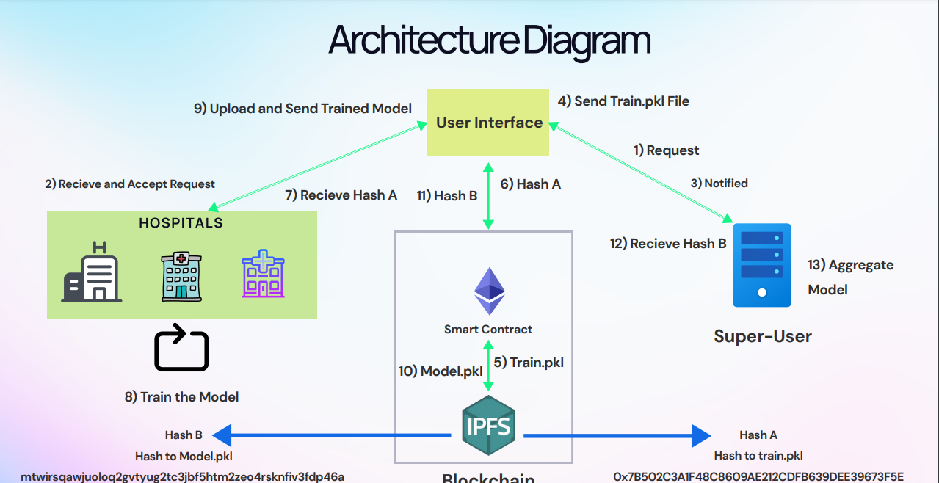

***Figure 12***

**High Level System Architecture**

## Software Architecture

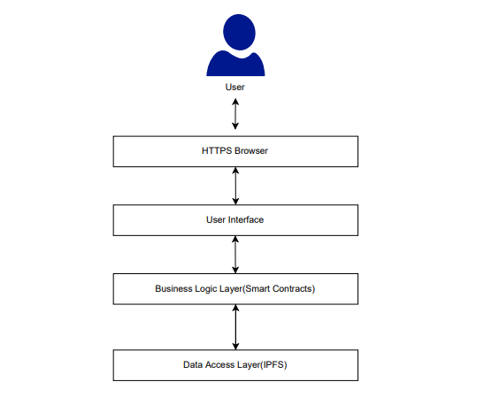

**Layered Software Architecture**

***Figure 13***

# **4.4 Development Tools Used**

The development tools and software technologies used are as follows:

* React JS
* Node JS
* Express JS
* Git version controlling
* PyCharm
* Visual Studio Code
* Postman
* Thunder Client
* Solidity
* Remix
* EtherJS
* Web3
* Hardhat
* MetaMask
* Ganache